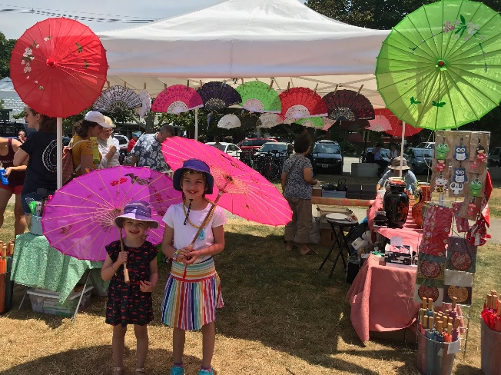
Artisans, Food Trucks, Vendors - Join The 40th Cultural Marketplace Fair
The Black Ships Festival – Saturday, August 12th, 2023 11:00am-3:30pm
Independence Park, Bristol, RI 419-459 Thames St, Bristol, RI 02809
Free event. Booth spaces are $75. This is a rain or shine event. Registration deadline is July 24, 2023. Link to the website application: https://www.blackshipsfestival.com/product-page/vendor-admission

Please fill out the application and email it to JASRhodeIsland@gmail.com along with up to five pictures of your work. Once the JASRI Executive committee reviews your application we’ll get back to you within three business days. If accepted Everett Hoag, our festival co-director will contact you with details and answer all questions.

Creatives, Local Artisans, and Food Trucks from across New England are invited to promote their own creations to the locals and visitors to Rhode Island at the Japan-America Society of Rhode Island (JASRI) 40th Annual Black Ships Festival… where creativity and community come together. Our goal is to forge new and lasting connections by inspiring cultural curiosity. The entire community is invited to attend and admission is free!

Shop local artisans from all over to make your experience unforgettable. Whether it’s Food Trucks, handmade crafts, rare comic books, original artwork, graphic novels, memorabilia, games, toys, costumes, t-shirts, or pastries – we want you here! We strive to offer a varied selection of creative and unique products for sale from approximately 60 vendors. The neat thing about our curated vendor lineup is that no two vendors are the same. Each vendor offers something very unique!

For more information JASRhodeIsland@gmail.com or call 401.622.4822. We’re looking forward to hearing from you!

Vendor Applicant Information
Vendor Contact: |  |  |  | Date:
 | Last | First | M.I.

Address:
 | Street Address | Apartment/Unit #

 | City | State | ZIP Code

Phone: |  | Email

Type of Products: |  | Business Website / Social Media: |  | Years in Business:

Business Name:

How did you hear about the Black Ships Festival):

Merchandise
Describe the items you will be selling:

Rules, Hours and Setup
The Black Ships Cultural Marketplace Fair is on Saturday, August 12th, 2023, from 11:00am-3:30pm in Independence Park, Bristol overlooking Narraganset Bay. This is a family-friendly event, so the Town of Bristol and JASRI ask for everyone’s cooperation in keeping this event safe and enjoyable for all.
- All booth space measures 10’ x 10’. Please bring your own tent, tables, chairs, change for transactions, and present your craft in an attractive display. All vendors must adhere to these limitations and keep merchandise and displays located within the designated space.
- Booths may be set up as early as 8:30 a.m. on the day of the Fair. Earlier setup can be arranged on a case-by-case basis. There is street parking available. We request that booths remain set up until the close of the Fair at 3:30 p.m.
- Materials cannot be left overnight.
- The registration fee is not refundable after July 15th 2023.
- All participants must have final approval by the JASRI Executive committee.

Disclaimer and Signature
* By submitting this form, you agree to pay all required fees upon acceptance and to remain in compliance throughout the event. If there is any damage to artwork or personal property, I will not find the Town of Bristol, the Japan-America Society and Black Ships Festival, Inc, its employees or agents liable. For more information email: JASRhodeIsland@gmail.com Or leave a VM at 401.622.4822.
.Signature: |  | Date:

OFFICE USE:
☐ Paying On www.BlackShipsFestival.com ☐ Check for $ _____________ (Payable to Japan-America of Rhode Island, Inc.) will be mailed to: The Japan-America Society of Rhode Island, Inc.
P.O. BOX 2543 - 169 BROADWAY
NEWPORT, RI 02840

